Invitation to Faith for Asian American Small Groups

Join God in His pursuit of Asian American students by making an invitation to faith in your AA small group! Use this guide to help you give a clear and compelling invitation via a Luke 15 bible discussion and art.

Prepare in Prayer
It is God who opens the hearts of our friends to receive the gift of eternal relationship with Him. Your single most important resource in making an invitation to faith is praying for yourself and your small group. Pause and do that now:

"Jesus, as I prepare to invite my small group to respond to you tonight, please give me courage and help open their hearts."

Key Practices when making an Invitation to Faith among Asian American Students:
Many AA students come from other faith backgrounds, hold stigmas associated with Christianity (i.e. Christians are only friends to convert you, Christianity is a white religion, etc.) or have little knowledge of Christianity and the Bible. Others have experience with Christianity and church but aren't actively pursuing faith for one reason or another. Considering this, include these 4 practices in your invitation to faith (script with practices below):

- Make it known at the beginning of the SG that an invitation to follow Jesus will be made during the meeting
- Spell out what repentance and putting faith in Jesus looks like (see “Choosing Jesus” section below).
- Acknowledge following Jesus is not about adopting a “Christian” title or culture but rather receiving the gift of a new relationship with God.
- Name that no matter how someone responds, all are still welcome and included in your community.
Invitation to Faith Script – Luke 15 Bible Study:
INTRO: Welcome everyone! Today, we are going to be looking at a story Jesus tells in the Bible that paints a picture of the uniqueness of God’s love. At the end of our time, I'll be sharing some ways we can respond to Jesus' love, and even consider following him with our lives.
SET THE SCENE: Jesus tells three stories about people or things that are lost and then found, and about the joy that comes when one sinner repents. We are going to look at the third story he tells, about a father and his two sons.

Read Luke 15:11-32 aloud. Then invite your group to re-read the passage quietly on their own [10mins]

DISCUSS [40mins]:
- How would you describe what the younger son is like? What in the story shows you that?
- How would you describe what the father is like? What in the story shows you that?
- What is surprising about the father’s response to his sons, and what would you have expected instead?
- Put yourself in the son’s place. How does it feel to have the father hugging and expressing his affection for you, even though you don’t deserve it?
- What does the father’s reception of his sons say about them?
- The father represents God in the story. How would you characterize God using the picture of the father in the story? How is this picture of God similar or different from who you imagine God to be?

TRANSITION TO THE GOSPEL [15mins]: As we’ve seen in this story, the God Jesus reveals is not a distant figure, but a God who profoundly loves those who have run away or misinterpret his character. A God who actively pursues a relationship with us. Let’s consider together what Jesus has done to allow us to have a real relationship with Him.

We’re going to look at some art created by an Asian American artist inspired by the story Jesus tells in Luke 15. We’ll take turns reading through each paragraph out loud.

Print out copies or text your group the next 2 pages. Have people take turns reading through page 1 out loud.

Page #1
God designed the world and our families to be loving places: where we are accepted, cherished, and loved not because of what we do but because of who we are. He created us for right relationship with him, with each other, and with the world. The image on the left represents our intended identities as God’s beloved children who love Him and one another.

But we thought we could run our lives better than God. Instead of placing God at the center, we put our own selfish desires at the center. In trying to find acceptance and love apart from God, we damaged all our relationships – with our family, others and with God. The image on the left represents this. Today we live in a broken, self-interested world that has many problems. We have depression, anxiety, loneliness, abuse, suicide, drug addiction, racism, shootings, war, etc. We deeply long for everything to be restored. Fortunately, God didn’t leave us in this mess.
God relocated into our world in the person of Jesus. He entered the mess and took the consequences of humanity’s brokenness onto himself. By dying on the cross, Jesus absorbed the consequences of our selfish, broken world. By rising again, He showed His power to heal and revive us despite our failings. If we’re willing to let God take his place at the center of our lives again and turn from our selfishness, we can be restored to a right relationship with him. The image on the left represents that we are restored and made worthy in God’s eyes not because of what we have done or failed to do, but because of what Jesus did for us. This is God’s grace.

Receiving God’s love and grace gives us a new security and joy that we can share with other people. Once we choose to follow Jesus, he sends us into the world to bring his love, healing, and justice wherever we go. We get to live and declare this good news as Jesus’ witnesses, living lives full of God’s love and courage. The image on the left represents that this is good news worth sharing! We are invited to think about who in our lives might need to hear this good news for themselves and to go share it with them.

Page #2

Ponder Your Response: Read the table silently and spend a few moments in quiet prayer
Choosing Jesus | Growing as a Witness
God wants us to trust Him, but He will never force us into a relationship with him. He invites us to choose. The Bible explains that choosing a relationship with God involves doing three things:  - Admit our selfishness has broken our connection with God  - Trust that Jesus’ death and resurrection can restore us  - Commit to put Jesus at the center of our lives and follow His leadership  Following Jesus is not about adopting a “Christian” label or culture but rather about receiving the gift of a new relationship with God. Doing these things is not easy. It takes courage to make Jesus the center of your life and follow his leadership.  Take a few moments in silence and ask Jesus: “Jesus, how are you inviting me to follow you?” | 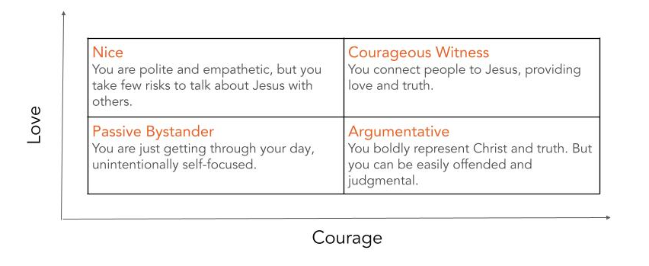  For those of us following Jesus, he invites us into deeper relationship with him by being a courageous witness and sharing God’s love with others. Look at this Love and Courage diagram. Which category best describes your mood this week?  Take a moment to pray, “Jesus, fill me with your love and courage. Please give me the joy of opening this story from Luke with some of the seekers and skeptics in my life. Bring a few people to mind right now.”

PONDER RESPONSE [8mins]: Give group 8mins in silence to read the table on page 2 and listen

INVITE (2mins): However you are feeling led to respond tonight, to choose to follow Jesus or to grow as His witness, take a few moments individually and in your own words ask Jesus to come into your life and help you follow His leadership.

Give group a few moments in silence to pray

CLOSING (10mins): Thank you for engaging and sharing tonight! However you responded…to choose Jesus, not to choose Jesus, give yourself more time to consider or to take a step towards becoming a courageous witness, I’m glad you are part of this community.

I would love to hear how you are responding. Let’s go around and please share something about how you are responding or have experienced our time today.

Close in prayer
After the Meeting
Individually follow-up with everyone (identifying Christians and non-Christians) asking:

- How did you experience our time?
- What did your response mean to you?
  - If said YES to Jesus: Let’s do something to celebrate! Would you be interested in meeting for discipleship with one of our leaders?
  - If said NO to Jesus: I’m glad you are part of our community. If you have questions about Jesus or Christianity, I’d love to chat more about them.
  - If STILL CONSIDERING: What is keeping you from choosing to follow Jesus? Can we pray together about those things?
  - If WITNESS: Who are some seeking or skeptical friends God is inviting you to share the story of Luke 15 with? Let’s pray for them now.

