BEC Community Map Worksheet
By Sara Kwon

Introduction
The goal of this training is to learn the Belong-Engage-Commit (BEC) Community Map for communal evangelism. What has been your experience of evangelism?

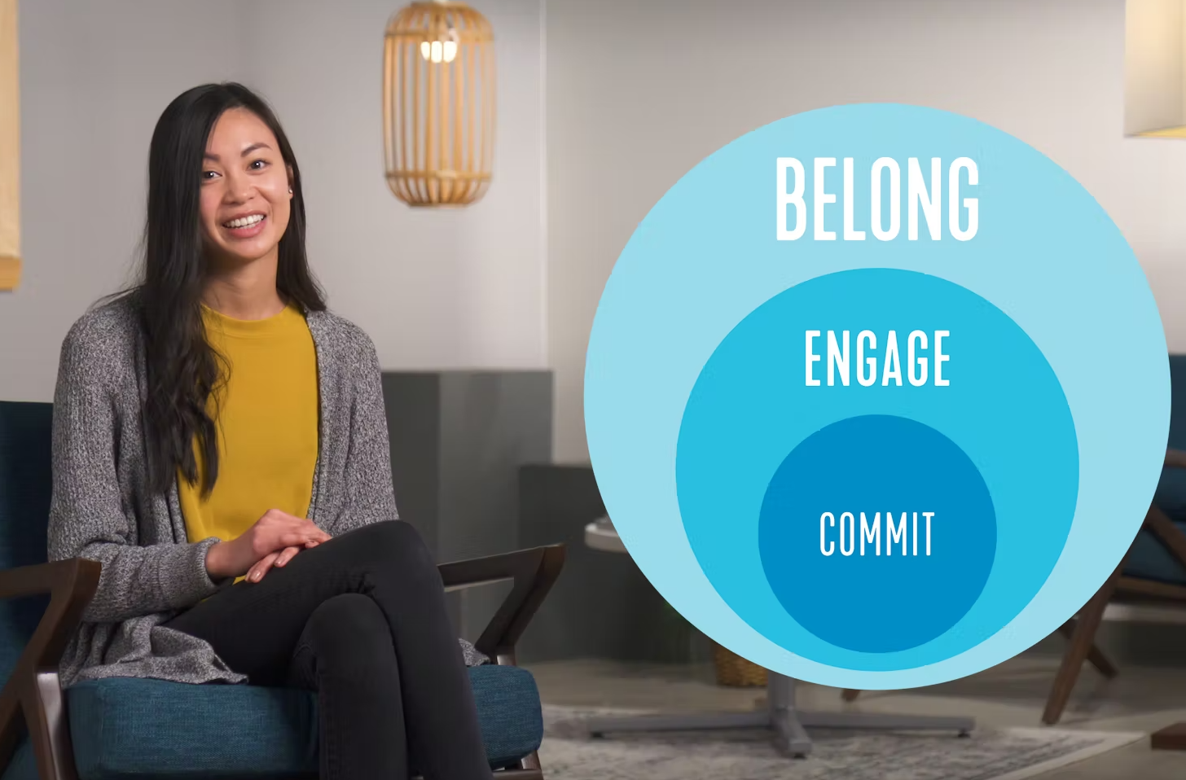
BEC Community Map Video (bit.ly/ivbecmap)
- How do you feel about doing evangelism as a community?
- Where have you seen belong, engage, or commit in your community? What stories of your own does this bring to mind?

Fill in the map to discover your community’s strengths.
SPACES What are some spaces/events your community likes to host? Place them on the map. | FRIENDS How connected are your friends to the community? Place them on the map.

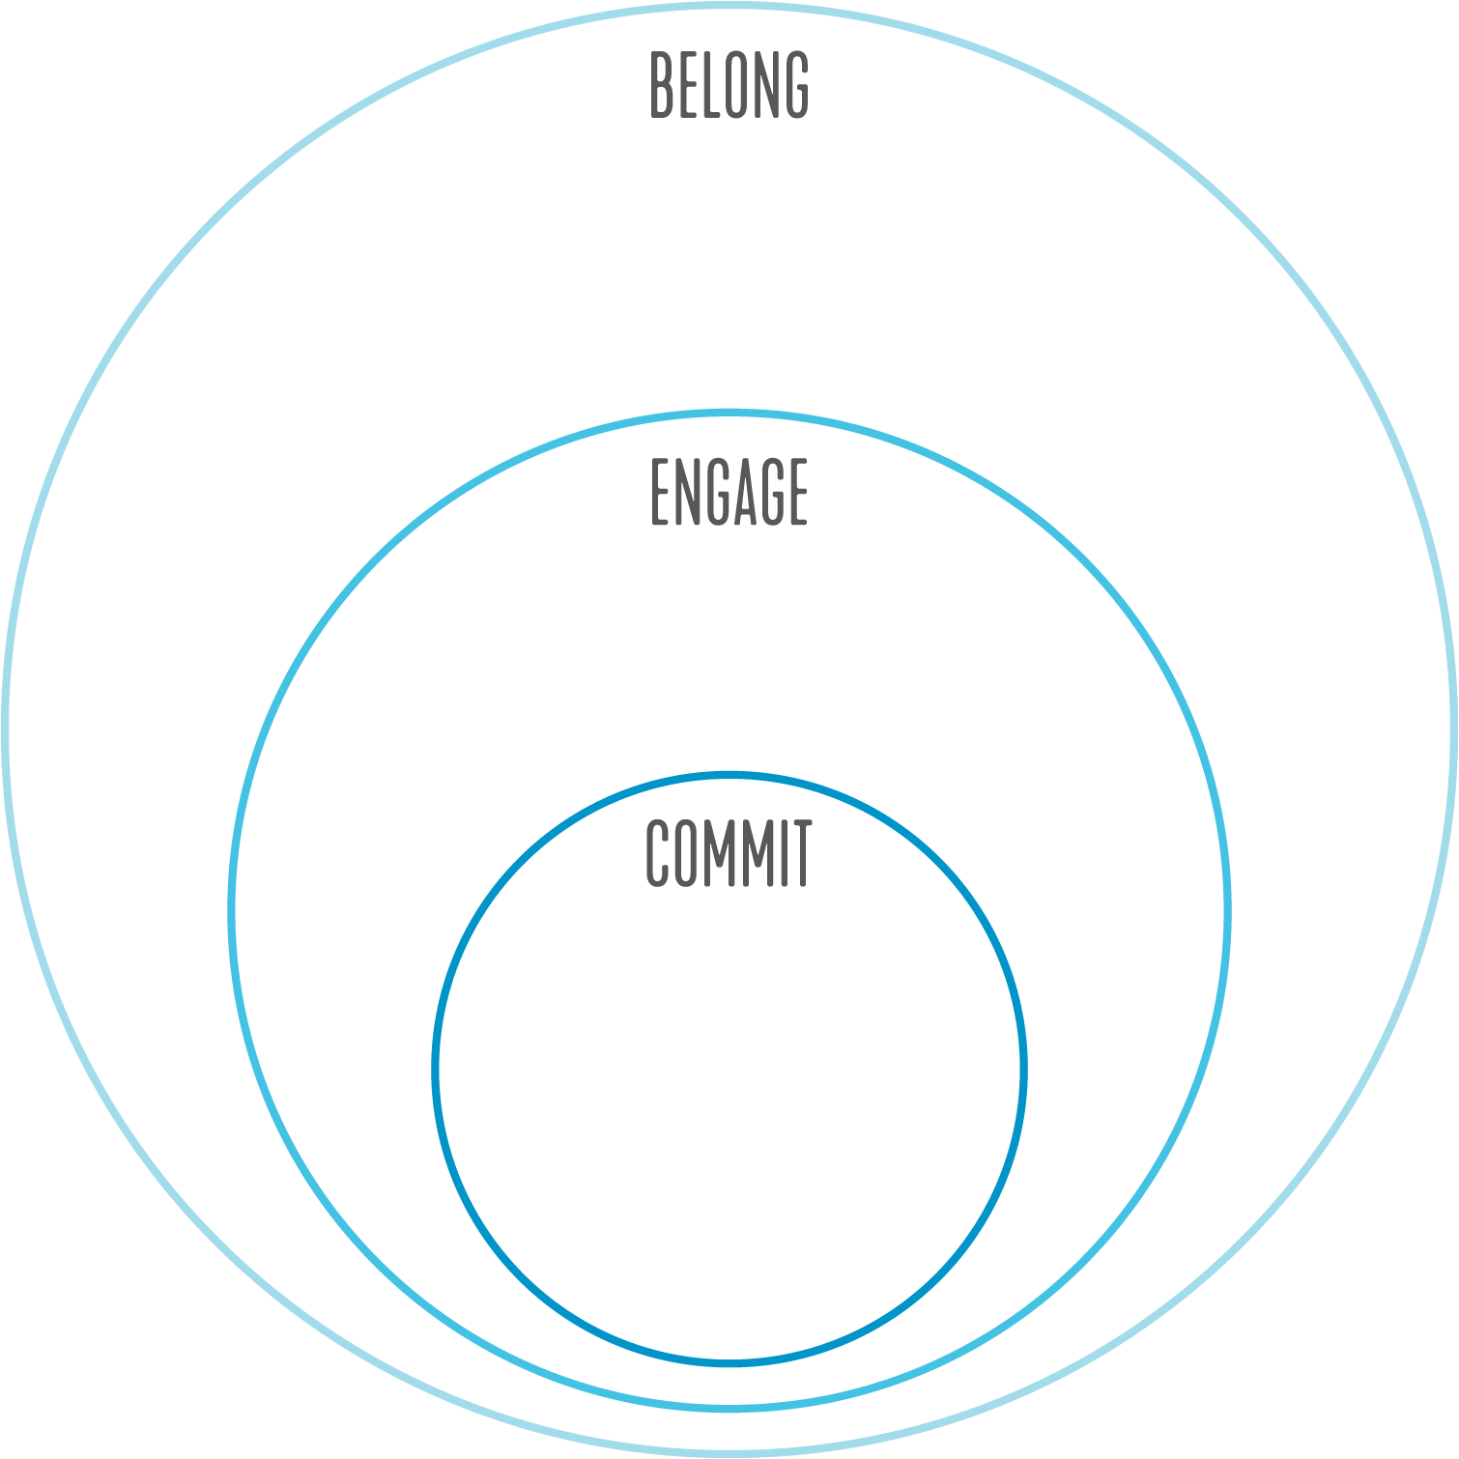
Observe & Interpret
COMMUNAL STRENGTHS Looking at the map, what are your community’s strengths in evangelism overall? What are your community’s strengths in Belong? Engage? Commit?

COMMUNAL CHANGES Looking at the map, where do you see opportunities for growth? What changes can your community make in Belong? Engage? Commit?

Chart 1: BEC Community Strengths & Changes
 | BELONG | ENGAGE | COMMIT
COMMUNAL STRENGTHS | - Hosting regular belong events for the community  - Meeting new people  - Inviting people to events and hangouts  - Regular follow up with new folks | - Hosting regular engage spaces to encounter Jesus  - Creating space for questions and uncertainty  - Asking good questions and listening  - Debriefing spiritual experiences with curiosity | - Hosting regular commit spaces for the community to reflect and consider making commitments to Jesus  - Sharing the Gospel in a way your friends can relate to  - Giving calls to faith  - Following up one-on-one
COMMUNAL  CHANGES | - Schedule regular low-pressure belong spaces so you can easily invite to the next thing  - Gather more contact cards via targeted tabling and outreach  - Make a follow-up plan (and follow through) so that every contact has 1-2 folks assigned to follow up with them  - Pray for newcomers during leaders meetings  - Make a communal network map and add to it periodically | - Schedule regular engage spaces and invite intentionally  - Use accessible language (don’t use Christian jargon) so newcomers can follow along  - Consider what people feel and experience, not just what they learn, in engage spaces  - Learn why people don’t return to your engage spaces  - Use 2+ cards to pray regularly, invite, and follow up intentionally | - Schedule periodic commit spaces and invite thoughtfully  - Incorporate commit reflection questions into engage spaces  - Give opportunities for guided listening prayer or Gospel contemplation experiences  - Practice naming (with humility) where you see God’s impact on your friends and ask them about it  - Foster a culture of sharing testimonies with realness

Next Steps
- DECIDE Decide on 1 area (B, E, or C) to focus on as a community and choose 1 change you need to make in this area. Choose from your list of changes or the chart above.
- IMPLEMENT Discuss how you will implement this change. Do 1 step this week.
  - Write down what you decided in step 1.
  - Brainstorm what your community needs to do to make this change. Identify at least 2-3 next steps.
  - When will you implement each step? What will you do this week?
  - Who will take lead for each step? What is each person’s role (if any)?
  - Schedule time to debrief and follow through on implementation at the next meeting.
- PRAY Pray together for your community and the friends you wrote on the map.

